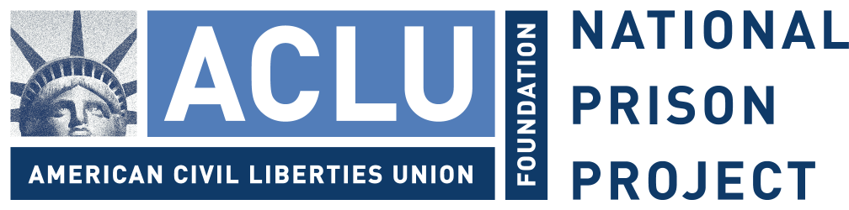

Michael A. Mason
Executive Assistant Director
Criminal Investigative Division
Federal Bureau of Investigations

August 8, 2006

Dear Mr. Mason:

The National Prison Project of the American Civil Liberties Union (NPP / ACLU), Human Rights Watch (HRW) and the NAACP Legal Defense and Educational Fund, Inc. (NAACP LDF) are writing to ask when the Federal Bureau of Investigations (FBI) will complete its inquiry into allegations of abuse at a number of correctional facilities during and after hurricane Katrina.

We are enclosing with this letter a comprehensive report by the NPP / ACLU documenting the abuses experienced by persons in the aftermath of the hurricane. Included in the report is a section co-authored by HRW and the NAACP Legal Defense and Educational Fund, describing the abuses we originally documented at Jena and that fall within the ambit of your agency’s investigations. We also enclose an excerpt from the recently adopted Conclusions of the Human Rights Committee (HRC), the body of experts entrusted with the enforcement of the International Covenant on Civil and Political Rights. As you will note, the HRC expressed its concerns about the alleged failure of evacuation plans after the hurricane. The Committee further instructed the United States to inform it about the results of inquiries into these matters, referring implicitly to your investigation.

As you may recall, Human Rights Watch and the NAACP LDF first wrote on October 7, 2005 to the Special Litigation Division of the Department of Justice to request an investigation into allegations of abuse during and after hurricane Katrina. In our letter we shared the results of our interviews with nearly two dozen detainees who presented consistent and detailed claims of physical abuse and mistreatment. On November 1, 2005, we received a response indicating that the Justice Department would not pursue the matter and that the FBI had been requested to conduct an investigation. On August 3, 2006 we were informed by your office that the investigation is ongoing.

We are therefore writing to you today to ask that the investigation be completed as soon as practicable and to recommend that it include inquiries into the treatment of prisoners throughout the affected region, including at Orleans Parish Prison, Elayn Hunt Correctional Center, Bossier Parish Maximum Security Jail, Ouachita Parish Correctional Center, and Jena. Moreover, since previous cursory investigations conducted by state department of corrections officials did not include interviews with inmates, we wish to highlight the importance of speaking directly to the prisoners who were incarcerated at the facilities at the time of the reported abuses.

Further, we hope that the FBI investigation underway includes assessments as to whether staff members were trained in department policies and whether they were properly supervised. A thorough investigation should also determine whether and to what extent prisoners have had access to grievance procedures.

We ask you to make your findings public, and to provide to state or federal prosecutors all evidence that could be used to hold accountable those responsible for abuse. We further urge the Department of Justice and state district attorneys to immediately and thoroughly pursue such prosecutions. Not only should the public know exactly what transpired at these facilities, but the victims must also see their abusers brought to justice.

Sincerely yours,

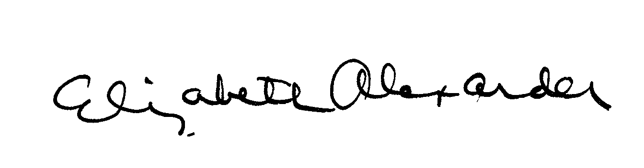
Elizabeth Alexander
Director
ACLU National Prison Project

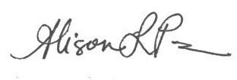
Alison Parker
Acting Director
U.S. Program
Human Rights Watch

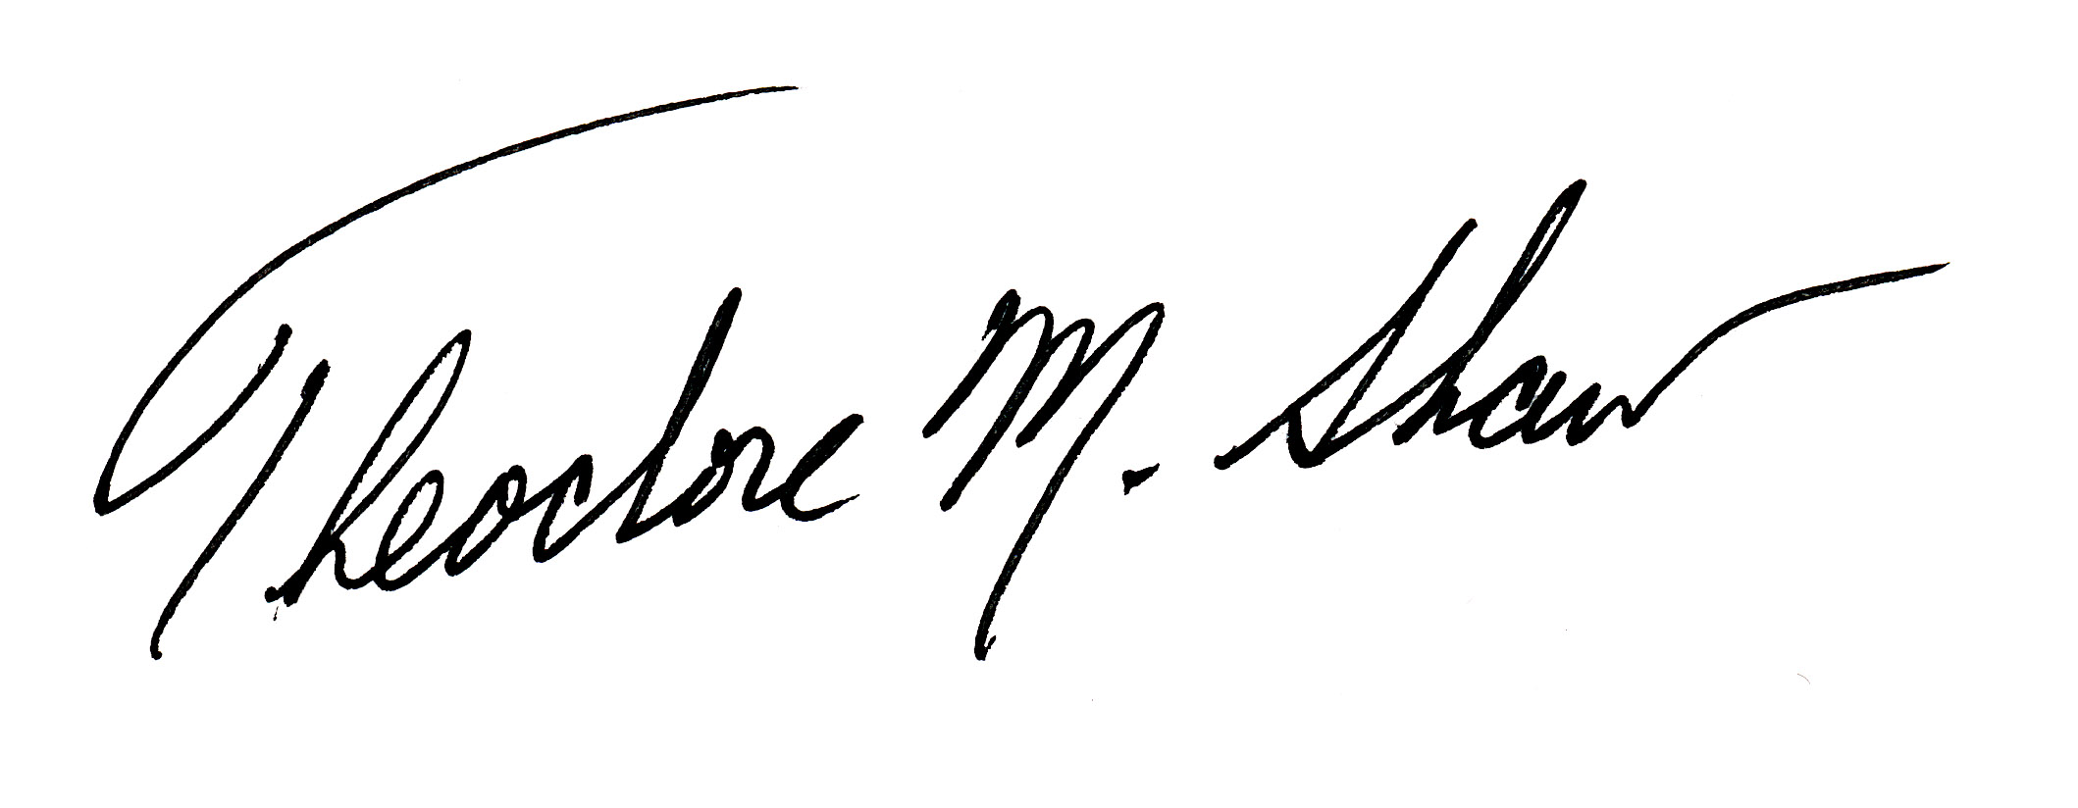
Theodore M. Shaw
Director-Counsel
NAACP Legal Defense and Educational Fund, Inc.

Cc:

Mr. Bradley J. Schlozman, Esq.
Acting Assistant Attorney General
U.S. Department of Justice
Civil Rights Division, Special Litigation Division
950 Pennsylvania Avenue, N.W.
Washington, D.C. 20530

Mr. Charles C. Foti, Esq.
Louisiana Attorney General
1885 North 3rd St.
Baton Rouge, LA 70802
P.O. Box 94005
Baton Rouge, LA 70804

Enc.

NPP / ACLU Report
Conclusion of the Human Rights Committee
HUMAN RIGHTS COMMITTEE
Eighty-seventh session
10-28 July 2006
CONSIDERATION OF REPORTS SUBMITTED BY STATES PARTIES
UNDER ARTICLE 40 OF THE COVENANT

ADVANCE UNEDITED VERSION
UNITED STATES OF AMERICA
Concluding observations

1. The Committee considered the second and third periodic reports of the United States of America (CCPR/C/USA/3) at its 2379th, 2380th and 2381st meetings (CCPR/C/SR.2379, 2380 and 2381), held on 17 and 18 July 2006, and adopted the following concluding observations at its 2395th meeting (CCPR/C/SR.2395), held on 27 July 2006.

* * *

26. The Committee, while taking note of the various rules and regulations prohibiting discrimination in the provision of disaster relief and emergency assistance, remains concerned about information that poor people and in particular African-Americans, were disadvantaged by the rescue and evacuation plans implemented when Hurricane Katrina hit the United States of America, and continue to be disadvantaged under the reconstruction plans. (articles 6 and 26)

The State party should review its practices and policies to ensure the full implementation of its obligation to protect life and of the prohibition of discrimination, whether direct or indirect, as well as of the United Nations Guiding Principles on Internal Displacement, in the areas of disaster prevention and preparedness, emergency assistance and relief measures. In the aftermath of Hurricane Katrina, it should increase its efforts to ensure that the rights of poor people and in particular African-Americans, are fully taken into consideration in the reconstruction plans with regard to access to housing, education and healthcare. The Committee wishes to be informed about the results of the inquiries into the alleged failure to evacuate prisoners at the Parish prison, as well as the allegations that New Orleans residents were not permitted by law enforcement officials to cross the Greater New Orleans Bridge to Gretna, Louisiana.

